Triacylglycerols produced by biomass of endophytic fungus Neopestalotiopsis surinamensis from the Scurrula atropurpurea leaves

Elfita¹*, Muharni¹, Mardiyanto², Fitrya², Elisa Nurmawati³, Hary Widjajanti³
¹Department of Chemistry, Faculty of Mathematics and Natural Sciences, University of Sriwijaya, Indralaya, Ogan Ilir, South Sumatra, 30662 Indonesia
²Department of Pharmacy, Faculty of Mathematics and Natural Sciences, University of Sriwijaya, South Sumatra, 30662 Indonesia
³Department of Biology, Faculty of Mathematics and Natural Sciences, University of Sriwijaya, Indralaya, Ogan Ilir, South Sumatra, 30662 Indonesia

*corresponding author: elfita69@gmail.com

Abstract. In Indonesia, Scurrula atropurpurea is a medicinal plant known as benalu. Triacylglycerols can be produced by plants, animals, algae, and microorganisms such as endophytic fungi. Triacylglycerols can be used in cosmetics, food, and medicine because they have biological activities such as antitumor, antibacterial, and cytotoxic. Besides, the compound can be used as a biodiesel substitute for triacylglycerols sourced from oil palm. This study aims to isolate and characterize triacylglycerol from biomass of endophytic fungal N. surinamensis from the S. atropurpurea leaves. The compound was isolated and purified by the column chromatography method. The structure of the compound was determined by spectroscopic data ( FTIR, ¹H-NMR, and ¹³C-NMR). Analysis of the spectrum and compared with the literature, the isolated compound is a triacylglycerol.
- Introduction
Endophytic fungi are microorganisms that live in plant tissue without causing harm to the host. Endophytic fungi have a high level of biodiversity. They can produce new bioactive compounds that are potentially exploited in the fields of medicine, food, agriculture, and industry [1-3]. Endophytic fungi are an excellent bioactive source due to its ability in producing bioactive in a short period and does not require a large growing area [4].
The lipid group that is commonly stored in plants is triacylglycerol (TAG), a fatty acid of triester bound to glycerol. Lipids serve as a carbon and energy reserves and are precursors for membrane lipids and steroid biosynthesis in plants. Besides, the microorganisms, such as endophytic fungi, also have a high ability to produce triacylglycerol, which is named with single cell oil. The triacylglycerol has potential commercial value as a food supplement, pharmaceutical, and biodiesel [5-7].
The fatty acids of triacylglycerol can be distinguished from long-chain alkyl (R) groups. The difference is in the chain's length, the number of double bonds, and the carbon position of the double bonds. There are two groups of fatty acids namely saturated fatty acids (SFA) and unsaturated fatty acids (mono and poly double bonds) [8]. Yinghua et al. (2009) examined clinical trials on female and male subjects that consumed medium and long-chain triacylglycerol. The results show that in male hypertriglyceridemia subjects, the triacylglycerol can reduce body weight and body fat and increase blood lipid profile. [9]. Previous similar studies have been carried out by Xue et al. (2009) on Chinese hypertriglyceridemic subjects. The result of consuming medium and long chain triacylglycerols can reduce body fat and blood triglycerides [5]. Triacylglycerol is also reported to inhibits triple negative mammary breast cancer cell proliferation [10]. Another study reported that the triacylglycerol of endophytic fungi as a source of biofuel precursors [11]. Fungal lipids containing polyunsaturated fatty acids (PUFAs) are valuable products because of their health promoting roles. The production of fungal lipids has many advantages, such as a short life cycle, less labor needed, less affection by place, season aclimateasier to scale up [12].
Previous studies have isolated the compound Quercetin-3-O-α-L-rhamnopyranoside from the liquid culture of fungus N. surinamensis from the S. atropurpurea leaves [13]. Besides, the biomass of endophytic fungi is a source of lipid fungal which has different the fatty acid composition. This study reported the stages of isolation and identification of fungal lipids from biomass of N. surinamensis. The triacylglycerol of lipid fungal produced by endophytic fungi is included in the raw material of non-edible oil that can be used as raw material for the pharmaceutical, food, cosmetics, and biodiesel industries.
- Materials and methods

Materials
The sterilization and medium for fungal growth used in this study include: alcohol 70%, distilled water, potato dextrose agar (PDA), and potato dextrose broth (PDB). The chemicals for the isolation of pure compounds include various organic solvents (methanol, ethyl acetate, n-hexane), for thin layer chromatography analysis (TLC, kiessel gel 60 F254 20 x 20 cm), stationary phase on column chromatography (CC, silica gel G 60 70-230 mesh).
  - endophytic fungal
Neopestalotiopsis surinamensis of Scurrula atropurpurea from stock fungus [13]. The fungal was identified molecularly in the biological research center-LIPI Cibinong.
  - Cultivation and extraction of N. surinamensis
The mycelia agar plugs (six pieces, 0.5 x 0.5 cm²) were inoculated with ose needles into 0.2 L potato dextrose broth (PDB) medium. The cultures were made in 3 L of PDB medium placed into 15 erlenmeyers. Incubation was carried out for three weeks at ± 27 ºC under static conditions. Furthermore, biomass was filtered using filter paper to separate from the broth cultures. The biomass is rinsed with distilled water and dried to a constant weight in an oven at 60 ° C. Dry biomass was ground and extracted by soxletation with methanol. Then the methanol extract was evaporated in the rotary evaporator to get concentrated extract [14, 15].
  - Isolation of triacylglycerol and identification of chemical structure
The concentrated MeOH extract (5.31 g) was separated by chromatographic techniques (CC) over stationary phase (silica gel, 50 g) and eluted with n-hexane-ethyl acetate (10:0→0:10). The eluates (10 mL) were collected in bottles and analyzed by TLC to obtain three subfractions (A-C). Fraction A (1.21 g) in the form of a mixture of oil was separated by CC (silica gel, 40 g) and eluted by n-hexane-ethyl acetate (10:0→9:1) to obtain a pale yellow oil (0.72 g). The oil was identified by IR, ¹H-NMR, and ¹³C-NMR spectrum, and compared with triacylglycerols spectrum from the literature.
- Results and discussion
  - Fungal lipids production
The fungal lipids (0.72 g) were obtained from the separation of 5.31 g dry of biomass by column chromatography. The yield obtained is 13.6%. The environment and the host of fungus are very influential in their ability to produce fungal lipids. Fungi that live in oily environments and oil-producing host plants have a higher ability to produce fungal lipids that reach 35% of the biomass's dry weight. The research shows that the fungal lipids from the biomass of endophytic fungal can be increased again by providing the right nutritional ratio for fungal growth media. The fungal needs a source of nutrients, including C, N, and P, for growth. These three nutrients can be varied by comparing to produce more fungal lipids [16].
The dry weight of biomass and fungal lipids content were obtained at different optimal incubation period for each fungus [17]. Beside, researched the highest fungal lipids content of the dry weight of biomass whose time varies for each fungus. The lipid was produced the highest at the optimal time and decreases the next day. Sources of carbon and nitrogen contained in the medium are reduced, then the lipids produced by fungi will be broken again into organic components that can be used as a source of nutrition for growth [18].
  - Identification of fungal lipids as triacylglycerol
The IR spectrum of fungal lipids from N. surinamensis and the spectrum of triacylglycerol from literature shown in Figure 1. A comparison of the two spectra was showed high similarity [19]. The significant peaks were appeared in signals 1747 - 1855 cm⁻¹, which confirmed the presence of carbonyl groups, and signals at 2855 - 2924 cm⁻¹ as the methyl groups.

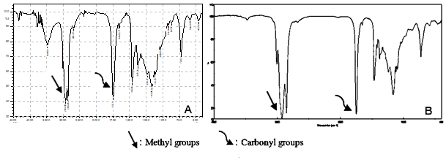

Figure 1. The IR spectrum of fungal lipids from N. surinamensis (A) and triacylglycerol from literature (B)

The ¹H-NMR spectrum of fungal lipids (Figure 2) showed the presence of the signals at the most downfield proton. The signal at 5.31 ppm (4H, m) confirmed the presence of unsaturated carbon (vinylic proton) in the long chain of the fungal lipids, followed by a signal for glyceryl methine proton at 5.25 ppm (1H, m). A signal at 4.27 ppm (2H, dd, 4.25 Hz) and a signal at 4.12 (2H, m) are two methylene groups attach at the glyceryl. The methylene groups attach to the ester carbonyl appear on the signal at 2.74 ppm (1H, t, J = 6.45 Hz), whereas the signal at 2.28 ppm (6H, m), 2.01 (6H, m), 1.59 (6H, m), represents the fatty acids moieties of fungal lipids. The terminal methyl protons were showed at 0.86 ppm (9H, m).
Harry-O’kuru et al. (2015) reported the ¹H-NMR spectrum of triacylglycerol from Maclura pomifera L. The chemical shift values of triacylglycerol at the most downfield signals as the vinylic proton at 5.4 ppm (9−10H), followed by a signal at 5.3 ppm (1H, m), which is the glyceryl methine proton. A signal at 4.3 ppm (2H, dd, J = 4.3 Hz) and a signal at 4.1 (2H, m) are the glyceryl CH2s. The signal at 2.75 ppm (4H, t, J = 6.6 Hz, 6.5 Hz) represents the methylene groups attach to the ester carbonyl, whereas the signal at 2.30 ppm (6H, m), 2.03 (11H, m), 1.6 (6H, m), represents the fatty acids moieties of triacylglycerol. The terminal methyl protons are the overlapping triplets (multiplet) at 0.87 ppm [20]. The ¹H-NMR spectrum of triacylglycerol from osage orange (M. pomifera L.) is similar to the ¹H-NMR spectrum of fungal lipids from N. surinamensis.

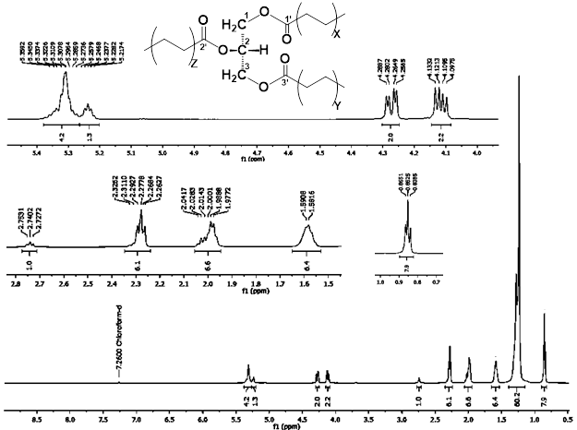

Figure 2. The ¹H-NMR spectrum of fungal lipids from N. surinamensis (¹H-500 MHz, in CD₃Cl)

The spectrum of ¹³C-NMR (Figure 3) showed the presence of three signals of glyceryl carbon (-CH-O-) at δ_{C} 69.0 ppm, (-CH2-O-) glyceryl at δ_{C} 64.5, 62.1 ppm and three ester carbonyls carbon at δ_{C} 173.2, 173.19, and 172.8 ppm, which is a characteristic of fungal lipids. Furthermore, the signal at δC 126-131 ppm indicated eight unsaturated carbon in the fatty acids moieties of fungal lipids, whereas the carbon at δ_{C} 10-35 ppm is saturated carbon from the fatty acids moieties.
Harry-O’kuru et al. (2015) reported the ¹³C-NMR spectrum of triacylglycerol from osage orange (M. pomifera L.). The chemical shift values of triacylglycerol showed the presence of three signals of glyceryl carbon (-CH-O-) at δ_{C} 68.9 ppm, (-CH2-O-) glyceryl at δ_{C} 62.0, 60.3 ppm, three ester carbonyls carbon at δ_{C} 173.17, 173.1, 172.7 ppm, which is a characteristic of triacylglycerol. The signal at δ_{C} 120-135 ppm indicated the presence of unsaturated carbon in the fatty acids moieties [20]. The ¹³C-NMR spectrum of triacylglycerol from osage orange (M. pomifera L.) is similar to the ¹³C-NMR spectrum of fungal lipids from N. surinamensis.
Based on the analysis of the spectroscopic data and compared with the literature, fungal lipids have a chemical structure as triacylglycerol. The structure of triacylglycerol from N. surinamensis is shown in Figure 4.

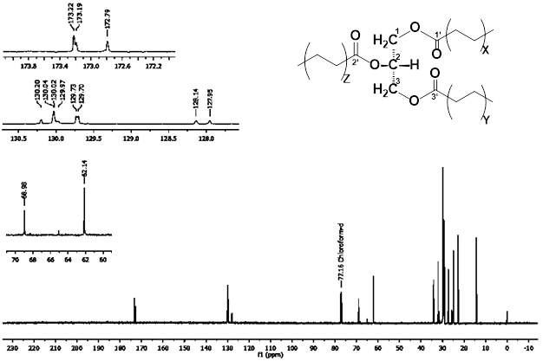

Figure 3. The ¹³C-NMR spectrum of fungal lipids from N. surinamensis (¹³C-125 MHz, in CD₃Cl)

Figure 4. The structure of triacylglycerol
The study of literature shows that an endophytic fungus can be developed as a source of fungal lipids if yield ≥ 20%. The yield of triacylglycerol from biomass of N. surinamensis needs to be improved through further research to find the optimum conditions, including the type of media, nutritional composition, pH, temperature, and incubation period [16, 19]. The research will open up opportunities in the supply of raw materials for the pharmaceutical, food, cosmetics, and biodiesel industries. The advantages of raw materials derived from endophytic fungi are that it does not require a large area of land, can be produced in a short time, low cost, and the same quality as raw materials from plants such as palm oil and castor oil.
- Conclusion
Separation of the biomass of N. surinamensis by column chromatography yielded the fungal lipids 13.6%. Base on the analysis by the spectroscopy method and compare by literature, the fungal lipids as a triacylglycerol. The research can be developed as raw material for the pharmaceutical, food, cosmetics, and biodiesel industries through further research to find the optimum conditions
Acknowledgments
The authors thankful to The Ministry of Research Technology and Higher Education (Kemenristekdikti) Republik Indonesia through “Hibah Penelitian Dasar Unggulan Perguruan Tinggi (PDUPT)” 2018-2020.
References
[1] Fadhillah F, Elfita E, Muharni M, Yohandini H, and Widjajanti H 2019 Chemical compound isolated from antioxidant active extract of endophytic fungus Cladosporium tenuissimumin in Swietenia mahagoni leaf stalks. Biodiversitas, 20(9) 2645-2650.
[2] Jie X, Lingling S, Xinran L, Qian W, Chuan W, Hui X, … and Qiao D 2013 Isolation and identification of oleaginous endophytic fungi. African Journal of Microbiology Research, 7(19), 2014-2019.
[3] Elfita E, Munawar M, Muharni M, and Sudrajat MA 2014 Identification of new lactone derivatives isolated from Trichoderma sp., an endophytic fungus of brotowali (Tinospora crispa). Hayati J. Biosci. 21 (2014) 15-20.
[4] Budiono B, Elfita E, Muharni M, Yohandini H, and Widjajanti H 2019 Antioxidant activity of Syzygium samarangense L. and their endophytic fungi. Molekul, Molekul, 14(1), 48-55.
[5] Xue C, Liu Y, Wang J, Zhang R, Zhang Y, Zhang J, ... and Wu J 2009 Consumption of medium- and long-chain triacylglycerols decreases body fat and blood triglyceride in Chinese hypertriglyceridemic subjects. European Journal of Clinical Nutrition, 63, 879-886.
[6] Avila P, Barrow J, Lucero M, and Aaltonen R 2011 Relationship between plant lipid bodies and fungal endophytes. Terra Lationoamericana, 30(1), 39-45.
[7] Anjum N, Pandey V, and Chandra R 2016 Exploitation of endophytic fungus as a potential souurce of biofuel. Carbon – Science and Technology, 8(2), 55-62.
[8] Di Pietro M, Mannu A, and Mele A 2020 NMR determination of free fatty acids in vegetable oils. Processes, 8(4), 410.
[9] Liu Y, Wang J, Zhang R, Zhang Y, Xu Q, Zhang J, … and Xue C 2009 A good response to oil with medium- and long-chain fatty acids in body fat and blood lipid profiles of male hypertriglyceridemic subjects. Asia Pac J Clin Nutr, 18(3), 351-358.
[10] Guardiola-Sarrano F, Beteta-Göbel R, Rodriguez-Lorca R, Ibarguen M, López D, Terés S, … and Escribá P 2019 The triacylglycerol, hydroxytriolein, inhibits triple negative mammary breast cancer cell proliferation through a mechanism dependent on dihydroceramide and Akt. Oncotarget, 10(26), 2486-2507.
[11] Florisvaldo S, Fill T, Nakamura J, Monterio M, and Rodrigues-Fo S 2011 Endophytic fungi as a source of biofuel precursors. Journal of Microbiology and Biotechnology, 21(7), 728-733.
[12] Akpinar-Bayizit A 2014 Fungal lipids: The biochemistry of lipid accumulation. International Journal of Chemical Engineering and Applications, 5(5), 409-414.
[13] Elfita E, Muharni M, Mardiyanto M, Fitrya F, Fera F, and Widjajanti H 2020 Antibacterial activity of traditional medicine Scurrula atropurpurea (BL) DANS and their endophytic fungi. Key Engineering Materials, 840, 205-213.
[14] Elfita E, Muharni M, and Munawar M 2015 Endophytic fungi isolated from sambiloto (Andrographis paniculata Nees) as a source of fungal lipid production. Journal of Chemical and Pharmaceutical Research, 7(9S) 66–69.
[15] Elfita E, Mardiyanto M, Fitrya F, Larasati JE, Julinar J, Widjajanti H, and Muharni M 2019 Antibacterial activity of Cordyline fruticosa leaf extracts and its endophytic fungi extracts. Biodiversitas, 20(12), 3804-3812.
[16] Dey P, Banerjee J, and Maiti MK 2011 Comparative lipid profiling of two endophytic fungal isolates -Colletotrichum sp. and Alternaria sp. having potential utilities as biodiesel feedstock. Bioresource Technology, 102(10) 5815–5823.
[17] Venkata Subhash G, and Venkata Mohan S 2011 Biodiesel production from isolated oleaginous fungi Aspergillus sp. using corncob waste liquor as a substrate. Bioresource Technology, 102(19) 9286–9290.
[18] Abu-Elreesh G, and Abd-El Haleem 2014 Promising oleaginous filamentous fungi as biodiesel feed stocks: Screening and identification. European Journal of Experimental Biology, 4(1), 576-582.
[19] Enshaeieh M, Abdoli A, Nahvi I, and Madani M 2013 Selection and optimization of single cell oil production from Rodotorula 110 using environmental waste as substrate. Journal of Cell and Molecular Research, 4(2), 68-75.
[20] Harry-O’kuru R, Tisserat B, Gordon S, and Gravett A 2015 Osage orange (Maclura pomifera L.) seed oil poly(α-hydroxydibutylamine) triglycerides: Synthesis and characterization . Journal of Agricultural and Food Chemistry, 63(29), 6588-6595.

