Studies on the controlled release of drugs from magnetic nanobiocomposites
Thomas Heinze^{1*}, Robert Müller², Mengbo Zhou¹, Martin Rabel³, Paul Warncke³, Dagmar Fischer³
¹ Institute of Organic Chemistry and Macromolecular Chemistry, Friedrich Schiller University of Jena, Humboldtstraße 10, D-07743 Jena, Germany
² Leibniz-Institute of Photonic Technology (IPHT), P.O.B 100239, D-07702 Jena, Germany
³ Department of Pharmaceutical Technology, Friedrich Schiller University of Jena, Otto-Schott-Straße 41, D-07745 Jena, Germany

Supplement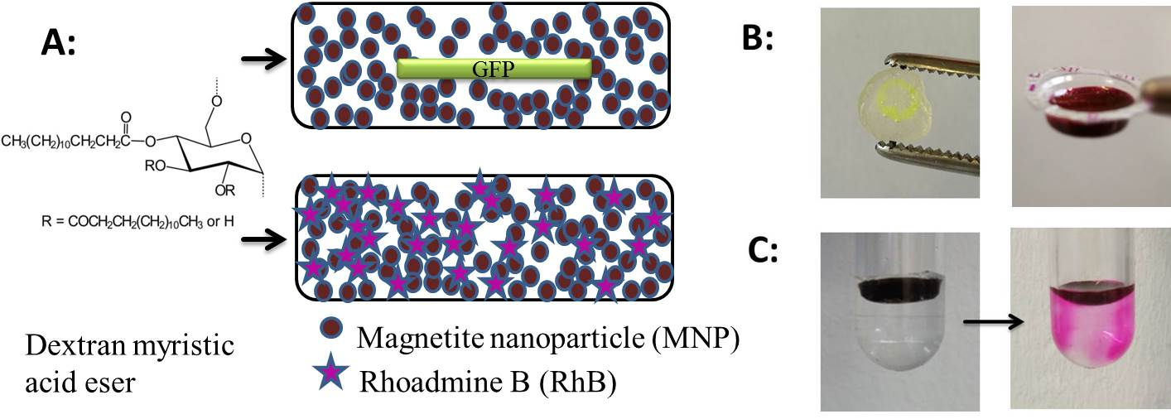
Figure S1. A: Scheme of magnetic nanobiocomposite obtained from magnetite nanoparticle and dextran myristic acid ester containing green fluorescence protein (GFP, above) and rhodamine B (RhB, below). B: GFP composite without magnetic particle (left) and RhB composite filled in a blister pack (right). C: Gradual heating generated with alternating magnetic field resulting in release of RhB
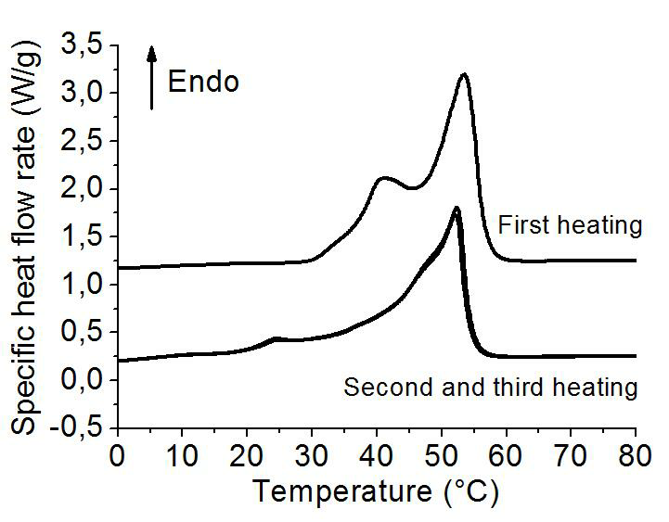
Figure S2. Thermal behavior of the magnetic nanobiocomposite (dextran myristate) studied by differential scanning calorimetry (DSC)
Calibration of concentration with spectrometric methods
The fluorescence intensity of GFP and absorption of Rhodamine B in UV-Vis spectroscopy could be variable after heating. Therefore, a water bath was used to heat up the GFP and RhB solutions to check if there is change on the absorbance after the heating condition as done by AMF. The correlation between spectroscopic intensity and numbers of heating cycle are showed in Fig. S2 and S3. It was found that the fluorescence intensity decreased slightly to 92% after 6 heating cycles in the water bath. This is comparable to the results in literature [1-3].
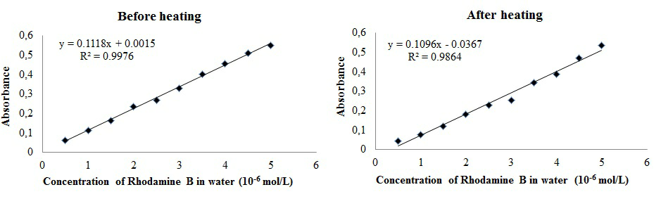
Figure S3. Calibration curves of rhodamine B (RhB, absorbance vs. concentration) before and after heating 5 heating cycles.
1. D. M. Sagar, S. Aoudjane, M. Gaudet, G. Aeppli, P. A. Dalby, Sci. Rep. 2013, 3, 2130.
2. A. Cao, Z. Ye, Z. Cai, E. Dong, X. Yang, G. Liu, X. Deng, Y. Wang, S.-T. Yang, H. Wang, M. Wu, Y. Liu, Angew. Chem. Int. Ed. 2010, 49, 3022.
3. I. A. Saeed, S. S. Ashraf, Int. J. Biol. Macromol. 2009, 45, 236.

